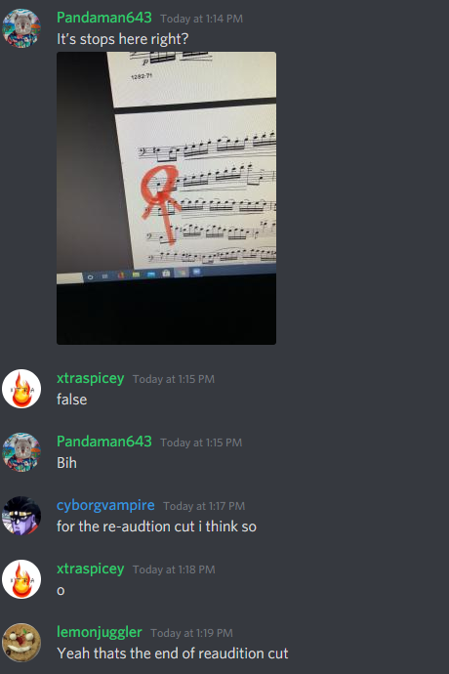

I am going to try to audition for a online band. I’ve been missing music a lot. I found a way to play with others online. I’m excited and hope I can push myself to do great things. Last year in high school my school placed 9th in the country and it was a life changing experience and I want to have music in my life forever.